|  |
| --- |
| Day 5 ( Responsive website ) |

**Task 1 -**

Create a responsive html page with bootstrap for below layout. You can use images from google.

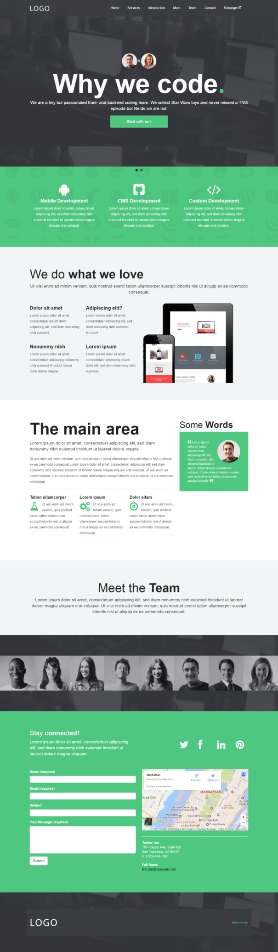

**Task 2**

Create a responsive html page with bootstrap for below layout.

